AP US History
Key terms assignment
Each week Students will select 10 key terms for that unit, from a variety of different course themes. You will explain Who, What, When and Where the person fits into US history. And then explain in your own words why this person is important, “Who cares”. Then you will create an illustration of that term and its importance. This should be complex illustrations that explains their importance, not just a simple images.
Ex.
John Winthrop:
He was one of the founders and governor of the Massachusetts Bay Colony. In 1629 the king of England Charles 1 granted a charter to the colony and it was settled a year later. The colony was founded on strict puritan beliefs and created what could be called a theocracy, under the leadership of Winthrop and others like John Cotton. Winthrop would go onto give a famous speech where he likened the new community they were creating to a “shining city on a hill”. The religious motivations of Winthrop would continue to influence the colonial history of the north throughout New England’s early history, and his idea of creating an idealized exemplar community in the Americas will continue to be referenced by American politicians and ideologues to today.
Not this: This:
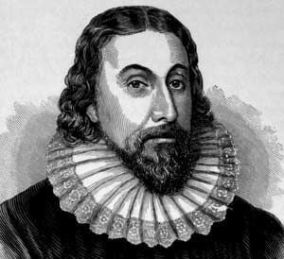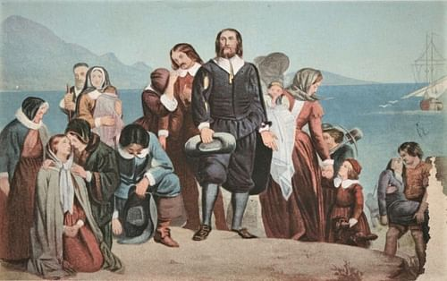

Grading
Each week’s key terms will be worth 10 points one for each term.
Plagiarism of any sort will result in a zero for the assignment

